 | Rajarata University of Sri Lanka  Department of Computing
 | COM 2303 – Web Design
Laboratory 05 – CSS Layout & Responsiveness
Time: 180 Minutes

Intended Learning Outcomes (ILOs)
By the end of this practical, students should be able to:
- Implement CSS Flexbox to create and manage one-dimensional (row or column) layouts.
- Implement CSS Grid to create and manage two-dimensional (row and column) layouts.
- Apply Media Queries to create responsive designs that adapt to different screen sizes.

Pre-Practical Preparation
Reading/Resources:
- Review the basics of CSS Flexbox and Grid: W3Schools CSS Introduction https://www.w3schools.com/css/css3_flexbox.asp
https://www.w3schools.com/css/css_grid.asp

Practical Objective
The goal is to apply modern CSS techniques to transform a simple HTML structure into a professional, responsive web application interface. Students will use Flexbox to align components, CSS Grid for overall page layout, and Media Queries to ensure a consistent experience across different device sizes.

Submission
At the end of the practical, save all your work in a folder renamed with your student ID (e.g., IT2024_12345) , compress it and upload to the LMS at https://lms.aps.rjt.ac.lk/mod/assign/view.php?id=45705

Practical Activity

Part 1: Flexbox Layout

Task 1: Using Flexbox Layout to create a Navigation Bar
- Objective: Use Flexbox to align a main logo/title and navigation items horizontally, ensuring optimal space distribution.
- Instructions: (For this task copy all your project folder from Day 2)
- Open the formatting.html file with your code editor.
- Create the following unordered list with links at the very top of the <body>.

Fig. 1. Target output of creating the unordered list with links
Sample code: To create the above link list insert the following <ul> structure at the very top of the <body>.
<ul class="navbar">
<li><a href="formatting.html">Home</a></li>
<li><a href="product-images.html">Products</a></li>
<li><a href="order-form.html">New Order</a></li>
<li><a href="order-summary.html">My Orders</a></li>
<li><a href="aboutus.html">About Us</a></li>
</ul>
- In an external CSS file (styles.css), apply display: flex; to the .navbar class.

Fig. 2. Output after applying display flex style to the unordered list
- Apply Flexbox properties to meet the following conditions to achieve the styles as in Figure 3:

Fig. 3. Output of the Navigation bar created after styling the unordered list with Flexbox
- Step 1: Initial Setup and Flexbox Activation
The goal here is to enable Flexbox and clean the page layout.
- Horizontal Layout: Ensure all <li> items display on one horizontal line (default style).
- Activate Flexbox and Remove List Formatting: Apply display: flex; to the .navbar class to place the list items horizontally.
- Then, remove the default list bullets with list-style: none; and spacing with margin: 0; padding: 0;.
- Alignment: Use align-items: center; (if you were using a container with height) and set a gap or margin between the links for visual separation.
- Apply a background color to the navigation bar. (#004942)
- Step 2: Styling the Links
The goal is to style the <a> tags to look like navigation buttons.
Format the Links: Target the links (<a> tags) inside the list items (<li>).
.navbar li a {
display: block; /* Makes the entire link area clickable */
text-decoration: none; /* Removes the underline */
color: #E5E9C5; /* Sets the text color */
padding: 14px 16px; /* Adds internal spacing around the text */
}
- Add a hover effect to the links with styling for interactivity.
Fig. 4. Output of the Navigation bar created after styling the anchor tags with hover effect
.navbar li a:hover {
background-color: #016B61;
color: #fff;
}

Task 2: Responsive Columns
- Objective: Use Flexbox to arrange content into multiple columns that wrap when the screen size changes.
- Instructions:
  - Open the product-images.html file in your code editor.
  - Linking CSS: Link a new, separate external CSS file named product-styles.css to this HTML page in the <head> section.
  - Add more products to better demonstrate wrapping. Sample code can be found at the end of the practical sheet.
  - Try to replicate output shown in Figure 5 using Flexbox wrapping.
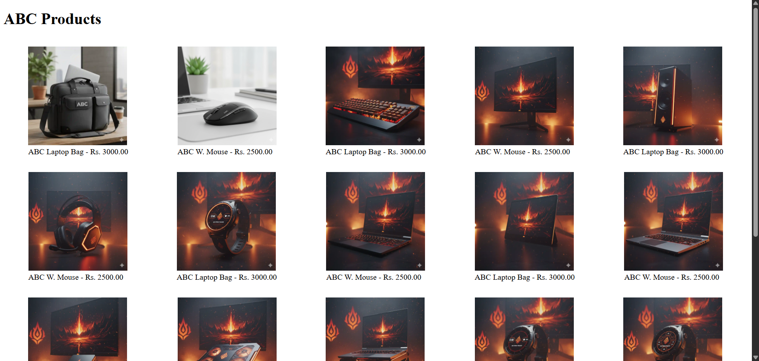
Fig. 5. Output after using flexbox wrapping for figure elements
Wrap all <figure> elements inside a new <div> container with the class .product-gallery
<div class="product-gallery">
…figure elements
</div>
  - Target the .product-gallery wrapper and apply the following rules to activate Flexbox wrapping.
.product-gallery {
display: flex; /* Arrange children horizontally */
flex-wrap: wrap; /* Allow items to move to a new line */
justify-content: space-around; /* Evenly space items horizontally */
}
  - View how the page response to screen size changes with resizing the browser window.

Part 2: CSS Grid Layout

Task 3: Basic Grid Structure
- Objective: Implement the fundamental structure of a multi-area webpage (Header, Sidebar, Content, Footer) using CSS Grid and the grid-template-areas property.
- Instructions:
- Create a new HTML file named grid-layout.html.
- Create a parent <div> with the class .grid-container to hold four child <div> elements, representing the major regions of the page. And create four child divisions in that parent <div> as in Figure 6.

Fig. 6. HTML structure for creating the grid template for Task 3
- Create an external CSS file named grid-styles.css and link it to the html file. Follow these steps to define the layout.
Step 1: Activate Grid and Define Areas
  - Activate Grid on the parent container (.grid-container) and give it the min-height: 100vh; to make it use the full height of the viewport.
.grid-container {
display: grid;
min-height: 100vh; /* Ensure the layout spans the full viewport height */
}
  - Then use grid-template-areas to assign a name to each position in the layout, creating a 3-row, 2-column structure.
.grid-container {
display: grid;
min-height: 100vh;

grid-template-areas:
"header header"
"sidebar content"
"footer footer";
}
Step 2: Define Row and Column Sizing
- Column Sizing: Define the width of the two columns using grid-template-columns. The sidebar is fixed at 250px, and the content area is fluid (1fr).
- Row Sizing: Define the height of the three rows using grid-template-rows. The header and footer size dynamically based on content (auto), and the content area takes the remaining vertical space (1fr).
Step 3: Assign Elements to Areas
- Assign the corresponding grid-area name to each structural element to place them into the grid structure. Provide a padding and a background color to easily identify each area.
.header {
grid-area: header;
background-color: aqua;
padding: 20px;
}

.sidebar {
grid-area: sidebar;
background-color: beige;
padding: 20px;
}

.content {
grid-area: content;
background-color: darkcyan;
padding: 20px;
}

.footer {
grid-area: footer;
background-color: coral;
padding: 20px;
}
  - View how the page response to screen size changes with resizing the browser window.
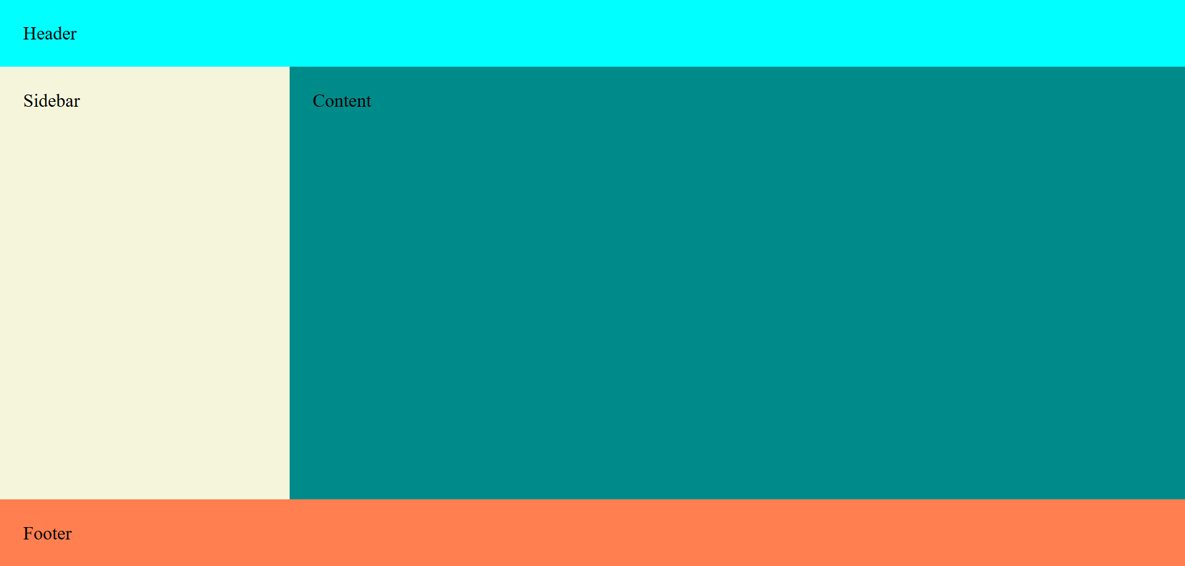
Fig. 7. Output after using grid layout on the webpage for task 3
Note: Grid vs. Flexbox
CSS Grid is used for two-dimensional layout, with rows AND columns.
CSS Flexbox is used for one-dimensional layout, with rows OR columns.

Part 3: Adapting to Different Screen Sizes

Task 4: Media Queries
- Objective: Apply media queries to make the layout responsive.
- Instructions: Apply a media query to your CSS Grid layout (from Task 1):
  - Apply a media query @media (max-width: 768px) to make the navigation bar we have created in Task 1 to stack vertically on mobile and tablet screens (see Figure 5).
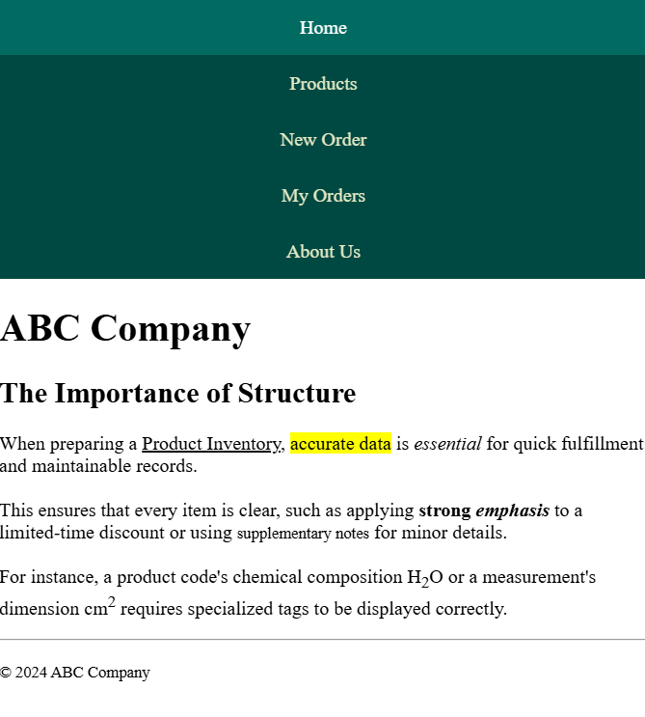
Fig. 8. After using media query to make the navbar responsive for mobile screen
@media (max-width: 768px) {
.navbar {
flex-direction: column;
}

.navbar li {
width: 100vw;
text-align: center;
}
}

Task 5: Challenge Activity (Optional)
You will convert the existing basic content into a modern, responsive Product Dashboard as in Figure 9. The final layout must use CSS Grid for creating the main structure, Flexbox for the header and product gallery, and Media Queries to ensure navigation bar adaptable between desktop and mobile views, matching the final design target.
For this task create a new HTML file named dashboard.html.
- To add the icon, you can use the Google material icons.
To add Google icons, add the following line inside the <head> section:
<link rel="stylesheet" href="https://fonts.googleapis.com/css2?family=Material+Symbols+Outlined" />
In the body section,
<div class="sidebar">
<h3>ABC Company</h3>
<ul>
<li><a href="#" class="active"><span class="material-symbols-outlined">devices</span> All Products</a></li>
<li><a href="#"><span class="material-symbols-outlined">laptop_mac</span> Laptpos</a></li>
<li><a href="#"><span class="material-symbols-outlined">desktop_windows</span> Monitors</a></li>
<li><a href="#"><span class="material-symbols-outlined">keyboard_alt</span> Accessories</a></li>
<li><a href="#"><span class="material-symbols-outlined">mobile</span> Phones and Tablets</a></li>
</ul>
</div>
In your style sheet you can define the font-size for the icon.
.material-symbols-outlined {
font-size: 16px !important;
}
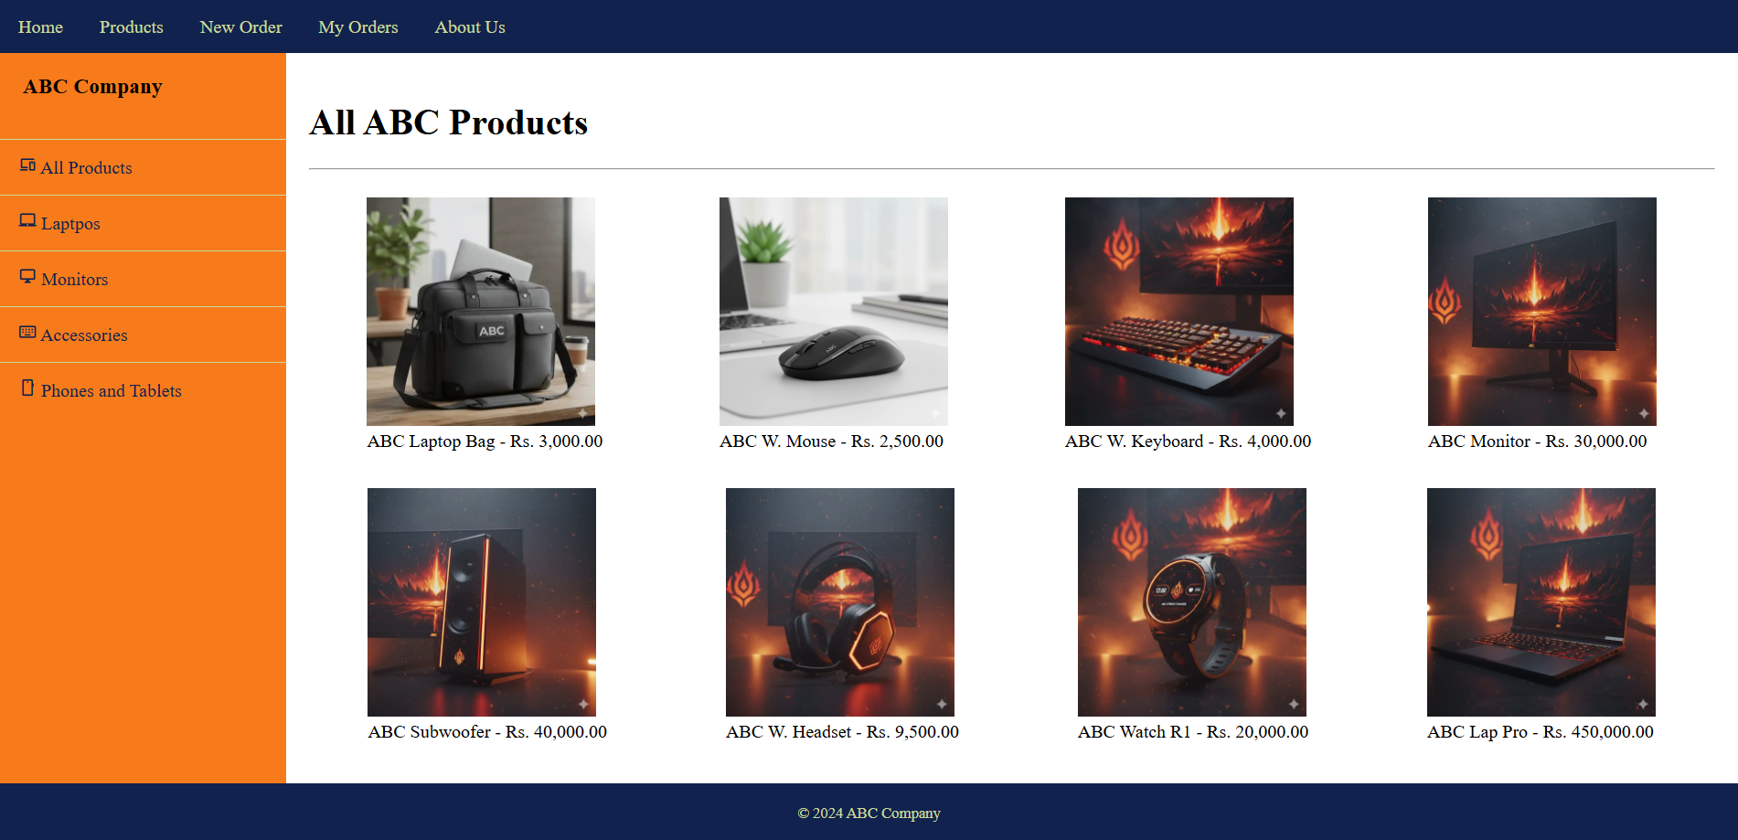
Fig. 9. Output for the Task 5 challenge
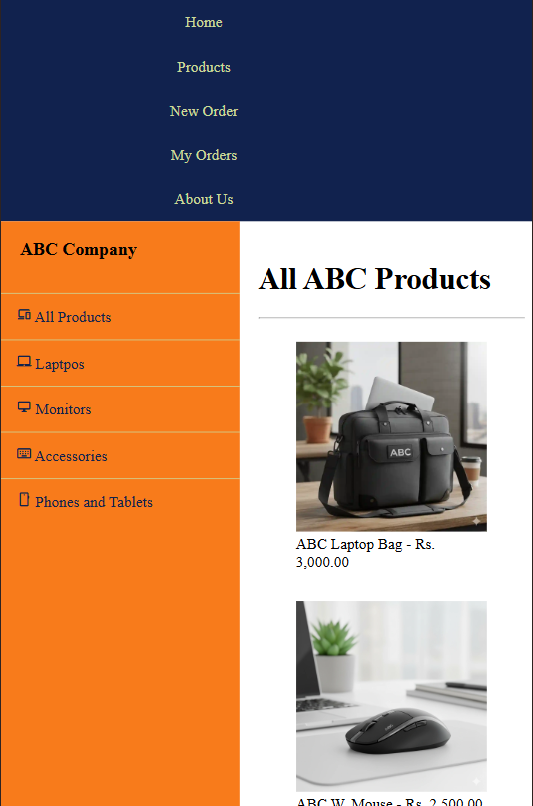
Fig. 10. Sample output for the Task 5 challenge in mobile view

Appendix
Code to add more figure elements for the task 2.
<figure><figcaption><img src="https://github.com/charith-ac/ict2204-com2303-practicals/blob/main/Resources/ABC_p3.webp?raw=true" height="200px" width="200px" /><figcaption>ABC W. Keyboard - Rs. 4,000.00</figcaption></figure>
<figure><figcaption><img src="https://github.com/charith-ac/ict2204-com2303-practicals/blob/main/Resources/ABC_p4.webp?raw=true" height="200px" width="200px" /><figcaption>ABC Monitor - Rs. 30,000.00</figcaption></figure>
<figure><figcaption><img src="https://github.com/charith-ac/ict2204-com2303-practicals/blob/main/Resources/ABC_p5.webp?raw=true" height="200px" width="200px" /><figcaption>ABC Subwoofer - Rs. 40,000.00</figcaption></figure>
<figure><figcaption><img src="https://github.com/charith-ac/ict2204-com2303-practicals/blob/main/Resources/ABC_p6.webp?raw=true" height="200px" width="200px" /><figcaption>ABC W. Headset - Rs. 9,500.00</figcaption></figure>
<figure><figcaption><img src="https://github.com/charith-ac/ict2204-com2303-practicals/blob/main/Resources/ABC_p7.webp?raw=true" height="200px" width="200px" /><figcaption>ABC Watch R1 - Rs. 20,000.00</figcaption></figure>
<figure><figcaption><img src="https://github.com/charith-ac/ict2204-com2303-practicals/blob/main/Resources/ABC_p8.webp?raw=true" height="200px" width="200px" /><figcaption>ABC Lap Pro - Rs. 450,000.00</figcaption></figure>
<figure><figcaption><img src="https://github.com/charith-ac/ict2204-com2303-practicals/blob/main/Resources/ABC_p9.webp?raw=true" height="200px" width="200px" /><figcaption>ABC aPad 12 - Rs. 100,000.00</figcaption></figure>
<figure><figcaption><img src="https://github.com/charith-ac/ict2204-com2303-practicals/blob/main/Resources/ABC_p10.webp?raw=true" height="200px" width="200px" /><figcaption>ABC Lap Air - Rs. 250,000.00</figcaption></figure>
<figure><figcaption><img src="https://github.com/charith-ac/ict2204-com2303-practicals/blob/main/Resources/ABC_p11.webp?raw=true" height="200px" width="200px" /><figcaption>ABC ext. HDD - Rs. 20,000.00</figcaption></figure>
<figure><figcaption><img src="https://github.com/charith-ac/ict2204-com2303-practicals/blob/main/Resources/ABC_p12.webp?raw=true" height="200px" width="200px" /><figcaption>ABC Cooling Pad - Rs. 3500.00</figcaption></figure>
<figure><figcaption><img src="https://github.com/charith-ac/ict2204-com2303-practicals/blob/main/Resources/ABC_p13.webp?raw=true" height="200px" width="200px" /><figcaption>ABC Lap stand - Rs. 2500.00</figcaption></figure>
<figure><figcaption><img src="https://github.com/charith-ac/ict2204-com2303-practicals/blob/main/Resources/ABC_p14.webp?raw=true" height="200px" width="200px" /><figcaption>ABC Watch R2 - Rs. 40,000.00</figcaption></figure>
<figure><figcaption><img src="https://github.com/charith-ac/ict2204-com2303-practicals/blob/main/Resources/ABC_p15.webp?raw=true" height="200px" width="200px" /><figcaption>ABC Watch R3 - Rs. 60,000.00</figcaption></figure>
<figure><figcaption><img src="https://github.com/charith-ac/ict2204-com2303-practicals/blob/main/Resources/ABC_p16.webp?raw=true" height="200px" width="200px" /><figcaption>ABC Watch L2 - Rs. 10,000.00</figcaption></figure>
<figure><figcaption><img src="https://github.com/charith-ac/ict2204-com2303-practicals/blob/main/Resources/ABC_p17.webp?raw=true" height="200px" width="200px" /><figcaption>ABC Powerbank - Rs. 9,000.00</figcaption></figure>
<figure><figcaption><img src="https://github.com/charith-ac/ict2204-com2303-practicals/blob/main/Resources/ABC_p18.webp?raw=true" height="200px" width="200px" /><figcaption>ABC Gx Mouse - Rs. 4,500.00</figcaption></figure>
<figure><figcaption><img src="https://github.com/charith-ac/ict2204-com2303-practicals/blob/main/Resources/ABC_p19.webp?raw=true" height="200px" width="200px" /><figcaption>ABC Mouse Pad - Rs. 1,000.00</figcaption></figure>
<figure><figcaption><img src="https://github.com/charith-ac/ict2204-com2303-practicals/blob/main/Resources/ABC_p20.webp?raw=true" height="200px" width="200px" /><figcaption>ABC Speakers - Rs. 15,000.00</figcaption></figure>

